## Installing Code Snippets

Code Snippets are reusable chunks of code, some of which have functionality in them to prompt developers using them. Code Snippets are included for exercises in these labs for both VB and C#.

The Code Snippets are installable via the VSI files located in this folder:   
*C:\WF\WF 3.5 Labs\Snippets*

* *Snippets_CSharp.vsi* – Installer for code Snippets for all C# code in the WF 3.5 labs.
* *Snippets_VB.vsi* – Installer for code Snippets for all VB code in the WF 3.5 labs.

#### Running the Code Snippet Installer

1. **Double-click** the *Snippets_CSharp.vsi* or *Snippets_VB.vsi* file.
2. The Visual Studio Content Installer dialog appears.

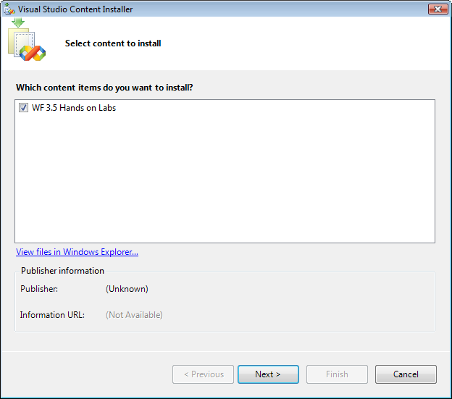

**Figure 1: Visual Studio Content Installer**

1. Click **Next**
2. If you are warned that the file is not signed choose **Yes** to proceed anyway.

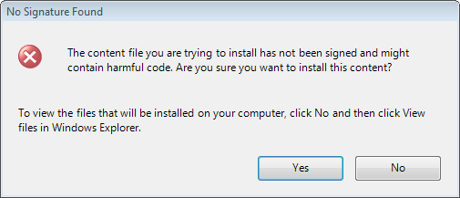

**Figure 2: Warning dialog**

1. Choose where you want to install the code snippets. Your dialog may only include “My Snippets” and if so, install the snippets there.

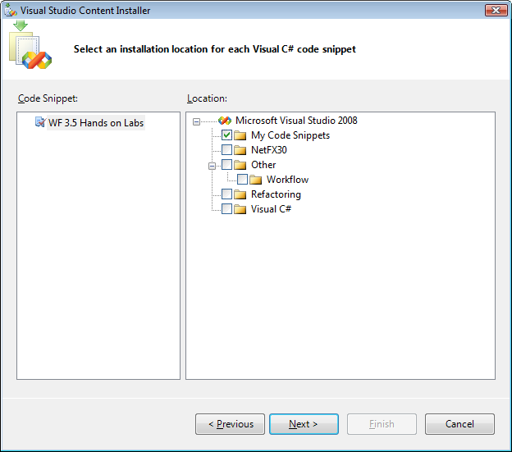

**Figure 3: Code Snippet location**

1. Click **Next**
2. **Click** Finish
3. Click **Close**
4. The Code Snippets are installed

# Using Code Snippets

All code required by this lab longer than two lines is available as Microsoft Visual Studio 2008 Code Snippets. There are two ways to insert Code Snippets in Visual Studio.

|  |
| --- |
| HOL Code Snippet Naming Convention All snippets in these labs start with **WFLab[Lab Number]_**  The exercises specify the name of the snippet to use when available. |

## Inserting Snippets with IntelliSense

1. Start typing the name of the snippet you wish to insert.
2. Use the arrow keys (Up, Down) to select the desired snippet.
3. Hit **TAB** 2 times to insert the snippet.

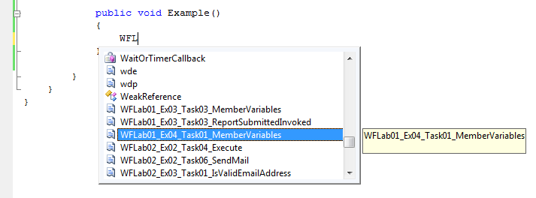

**Figure 4: Inserting a snippet with IntelliSense**

## Inserting Snippets with the Context Menu

1. **Right-click** your mouse in the code editor
2. Choose **Insert Snippet**
3. The code snippets associated with this lab are accessed in **My Code Snippets | <Name of Lab>**.

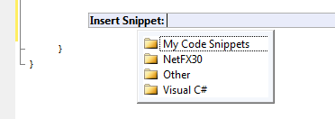

**Figure 5: Inserting a Snippet via Context Menu, Step 1**

1. **Double-click** the code snippet you wish to insert.

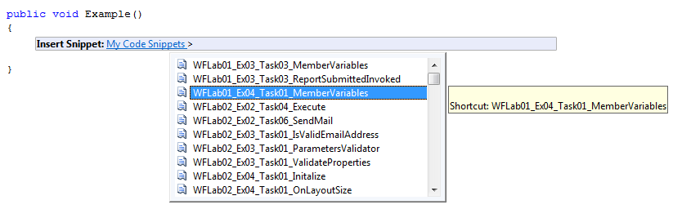

**Figure 6: Inserting a Snippet via Context Menu, Step 2**